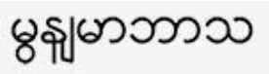 | Burmese

ACAT – INTERPRETER CARD

The use of an accredited interpreter is required by:

- ACT Government policy and legislation;
- Good practice and commitment to client quality outcomes.

To provide a client with this card, please:
- Print this sheet;
- Cut out the card (along the red lines); and
- Create a wallet-sized card (fold along the dotted red line)

PLEASE ARRANGE FOR AN INTERPRETER

I speak: Burmese

ACT Government policy requires the ACT Civil and Administrative Tribunal administration to provide interpreters free of charge to people with limited English proficiency. Please arrange an interpreter in the language shown on the front of this card through TIS National (131 450). You will also need your work area’s TIS Client Code.

